Data Analytics Mini Project
Name: Harishma G
Batch: DA 39
Superstore Sales Data Analysis Using Excel and Power BI
Data Source: https://www.openml.org/search?type=data&status=active&id=43383
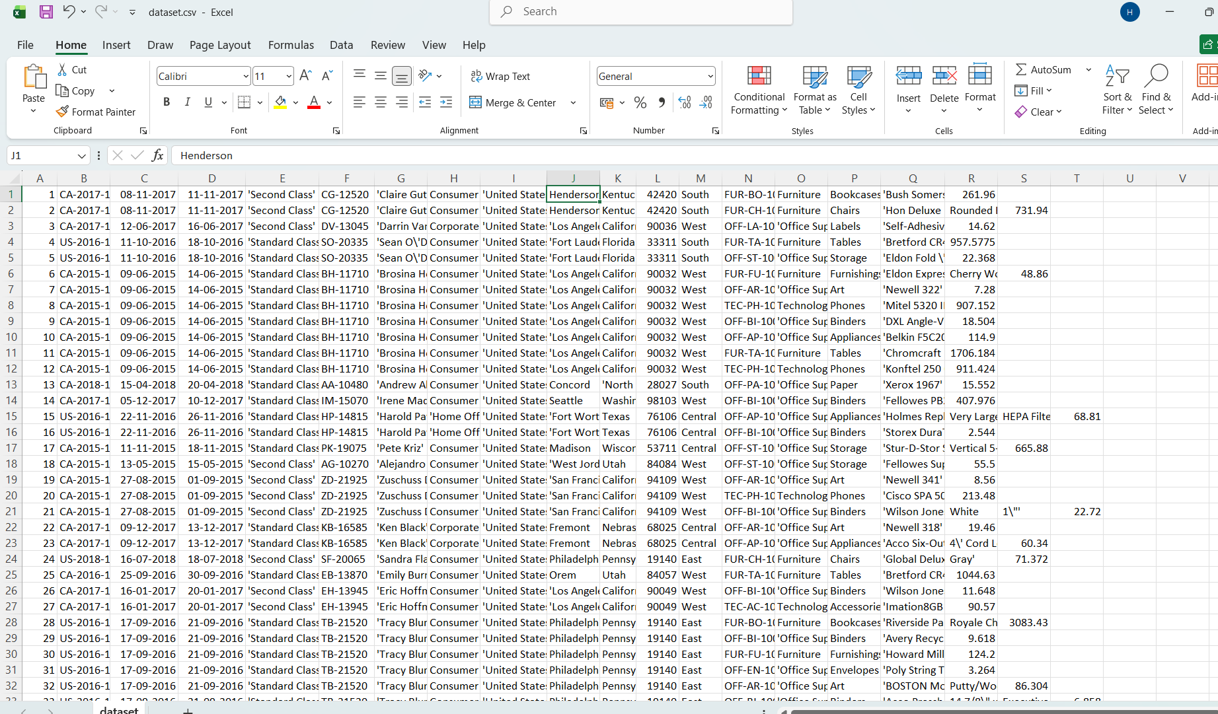
1. Introduction
Data preprocessing is an essential step in data analytics because raw datasets often contain inconsistencies, missing values, formatting issues, and duplicate records. These issues can affect the accuracy of analysis and visualization. Therefore, cleaning and transforming the data is necessary before performing data analysis.
In this project, a sales dataset was used to demonstrate the process of data preprocessing and visualization. The dataset was cleaned and transformed using Excel and Power Query techniques. After preprocessing, the cleaned dataset will be used to create interactive dashboards in Power BI for analysing sales trends and business insights.
2. Scope of the Project
The scope of this project is to apply data preprocessing techniques to a real-world dataset and prepare it for data analysis and visualization.
The project involves:
- Selecting an appropriate dataset with sufficient records and attributes
- Performing data cleaning and transformation using Excel and Power Query
- Handling missing values and inconsistent data formats
- Creating calculated columns required for analysis
- Preparing the cleaned dataset for visualization in Power BI
The final goal of the project is to transform messy and unstructured data into a clean and structured dataset suitable for business analysis.
3. Objective of the Project
The main objective of this project is to understand and apply data preprocessing techniques in a real-world dataset. The project focuses on improving data quality and preparing the dataset for meaningful analysis.
The key goals of the project include:
- Cleaning messy and inconsistent data
- Handling missing values and errors
- Standardizing column formats
- Creating calculated columns for analysis
- Preparing the dataset for visualization in Power BI
4. Dataset Description
The dataset used in this project is a superstore sales dataset obtained from a public data source. The dataset contains approximately 9800 records information about customer orders, product details, sales values, and shipping information.
The dataset includes attributes such as:
- Order ID
- Order Date
- Ship Date
- Ship Mode
- Customer Name
- Customer ID
- Region
- Postal Code
- Product ID
- Segment
- Country, City, and State
- Product Name
- Sales Value
Initially, the dataset contained messy and inconsistent formatting, including missing values, mixed columns, and formatting issues. Therefore, several preprocessing steps were applied to clean and organize the dataset before analysis.
5. Data Preprocessing Steps
Several preprocessing techniques were applied to improve the quality and structure of the dataset.
5.1 Handling Missing Postal Codes
Some records in the Postal Code column contained missing values represented by the symbol "?". These missing values were replaced with the correct postal code for Vermont to maintain data consistency.
5.2 Merging and Splitting Columns
Columns 17 to 23 contained messy data where product names and sales values were spread across multiple columns. These columns were first merged and then split using delimiters to separate Product Name and Sales into individual columns.
5.3 Correcting Sales Data
The Sales column was converted into decimal format to allow proper numerical analysis. The column header was also renamed appropriately.
5.4 Handling Errors
One row in the Product Name column and Sales column contained errors during transformation. These values were replaced with "Unknown Product" to maintain consistency in the dataset.
5.5 Renaming Column Headers
The dataset initially did not contain column headers within the table. Column names were assigned based on the features provided in the dataset description.
5.6 Standardizing Data Formats
Several columns were formatted to maintain consistency.
Order Date and Ship Date were converted to date format, and columns such as Ship Mode, Customer Name, Segment, Country, City, and State were cleaned and standardized to remove special characters.
5.7 Creating Calculated Columns
Additional columns were created to support analysis:
- Shipping Days – calculated from the difference between ship date and order date
- Order Year – extracted from the order date
- Month Number and Month Name – created to analyse monthly sales trends
- Delivery Status – categorized deliveries as Fast, Normal, or Delayed based on shipping days
5.8 Removing Duplicate Records
Duplicate records were identified using the combination of Order ID and Product ID, which uniquely identifies each product within an order. After removing duplicates, the dataset size reduced from 9800 rows to 9793 rows, indicating that 7 duplicate records were removed.
5.9 sorting and Filtering
Sorting and filtering techniques were used during the preprocessing stage to inspect the dataset and identify potential data quality issues. For example, the Sales column was sorted in descending order to check for extremely large or incorrect values. Filters were applied to columns such as Product Name, Postal Code, and Sales to identify blank values, special characters, or incorrect entries.
5.10 Final Cleaned Dataset
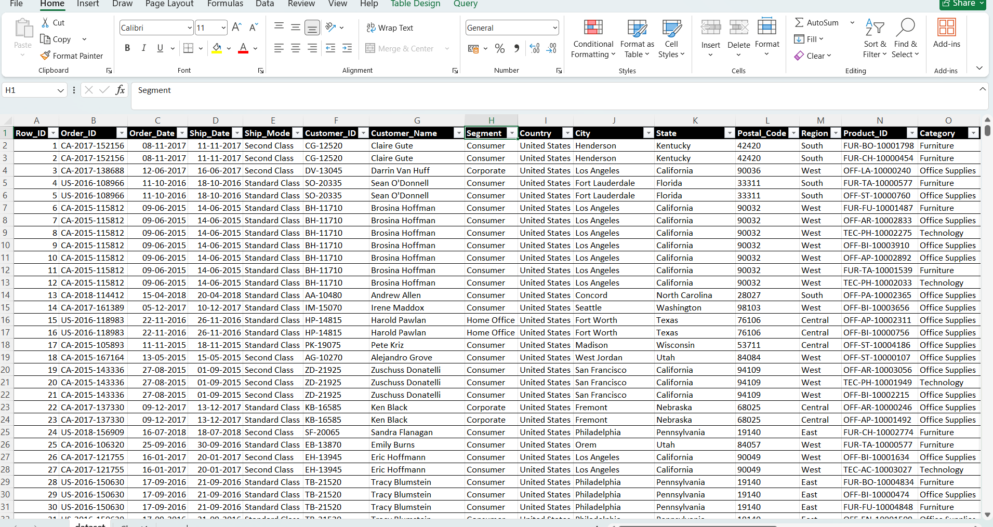
6. Measures and Calculations
After completing data preprocessing, several measures and calculated columns were created in Power BI to support analysis.
- Measures created:
- Total Sales – Sum of sales values
- Total Orders – Count of orders
- Total Customers – Distinct count of customers
- Average Order Value – Total Sales / Total Orders
- Average Shipping Days – Average difference between order date and ship date
- Calculated Columns:
- Shipping Days – Difference between Ship Date and Order Date
- Order Year – Extracted from Order Date
- Month Name – Used for monthly trend analysis
These measures helped in summarizing and analysing the dataset effectively.
7. Dashboard Development and Visualization
An interactive Power BI report was created to visualize sales performance and business insights. The report consists of three main pages:
1. Overview Page
- Displays key KPIs such as Total Sales, Total Orders, Total Customers, Average Order Value, and Average Shipping Days
- Includes charts:
  - Sales by Category
  - Sales by Region
  - Sales by Month (trend analysis)
  - Sales by Sub-category
This page provides a high-level summary of overall performance.

2. Category Analysis Page
- Focuses on product-level insights
- Includes:
  - Sales by Sub-category (Top-performing products)
  - Sales by Category (Tree map)
  - Sales by Segment (Pie chart)
  - Sub-category-wise order details (Matrix)
Helps identify best-performing categories and products.

3. Region & Shipping Analysis Page
- Focuses on geographical and logistics insights
- Includes:
  - Top 10 States by Sales
  - Sales by State (Map)
  - Orders by Ship Mode
  - Sales by Region
  - Sales by Month
Provides insights into regional performance and shipping behaviour.

9. Key Insights
- The West region contributes the highest sales
- Technology category generates the most revenue
- Certain sub-categories like Phones and Chairs show strong performance
- Standard Class shipping is the most frequently used mode
- Sales show an increasing trend towards the end of the year

10. Conclusion
The project successfully demonstrates how raw sales data can be transformed into meaningful insights using Power BI. Data preprocessing improved data quality, and interactive dashboards enabled better understanding of sales trends, customer behaviour, and regional performance.
The analysis highlighted key findings such as higher sales in the West region, strong performance of the Technology category, and the impact of shipping modes on orders.
The final report helps in making informed business decisions based on data-driven insights.

